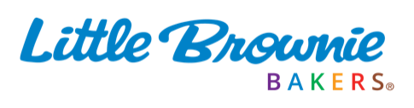
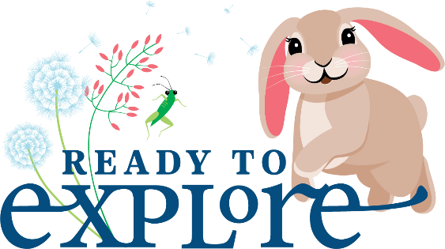
Girl Scout Cookie™ Rally
2026–27 Welcome Script
Overview:
Welcome adventurous entrepreneurs to your Girl Scout Cookie Rally with this customizable script. They’ll leave feeling energized, confident, and Ready to Explore the season ahead!

Summary:
This script previews key topics Girl Scouts will need to know going into this season: this year’s theme, the new mascot, rewards they can earn, and — of course — cookies!
Customize it to your council’s needs by choosing which topics you want to feature and filling in the blanks. You can either use the suggested copy or swap it out with info specific to your council.

Optional supplies and setup:
- Microphone, speakers or other AV equipment
- Presentation and screen for any supporting visuals
- Cookie overview video
- Fun and upbeat music

INTRO:
Hello, Girl Scout entrepreneurs, and welcome to the 2026-27 Girl Scout Cookie Season! Are you ready to rally?!
Awesome! My name is ________, and I’m thrilled to kick off this season with you at our
Girl Scout Cookie Rally!
Today, you’re going to have tons of fun learning about delicious Girl Scout Cookies®, rewards you can earn, and you’ll explore new ways to run your very own cookie business!

THEME:
This year’s theme is READY TO EXPLORE. So we will be jumping into this season with curiosity, courage, and ready to try new things. So, let me ask you. What do you think?
Are you READY? (WAIT FOR RESPONSE)
Are we EXPLORERS? (WAIT FOR RESPONSE)
Are Girl Scouts READY TO EXPLORE? (WAIT FOR RESPONSE)
Yes! Girl Scouts are absolutely READY TO EXPLORE!
This year, you’ll discover new skills, new confidence, and new possibilities as you go on your cookie adventure. Think of this season as your personal expedition — exploring your business and discovering your strengths.
As Girl Scouts, you're learning how to think like entrepreneurs.
Starting today, you’ll learn 5 important skills: Goal Setting, Decision Making, Money Management, People Skills and Business Ethics. When you work together in the cookie program, you’ll develop these 5 skills and grow into amazing leaders!

MASCOT:
This season is going to be a great adventure. And every great adventure needs a guide. This year, we are joined by a fun and curious lop-eared rabbit named Sally. Sally is always hopping into new adventures and is Ready to Explore right along with you.
Today, we’ll discover fun facts about lop-eared rabbits and why they make the perfect mascot for a season all about curiosity and exploring new skills. You’ll even get to preview the rabbit plush reward you can earn!

REWARDS:
Speaking of rewards… this year’s lineup is full of gear and experiences perfect for explorers!
[display presentation with reward photos and number of packages needed to earn them]
We have outdoor gear perfect for camp, must-have fashion accessories, mascot rewards and special troop experiences waiting for you. [insert experience details and more information]
We’ll also show you how to make a plan so you can hop closer to the rewards you want most. And don’t forget, you can find all these rewards listed on your order card.

COOKIES:
Now, let's talk about everyone’s favorite topic — cookies!
Girl Scout Cookies are made by Little Brownie Bakers who use top-quality ingredients to bake all of your favorites. Little Brownie puts care and quality in every batch of cookies. From the minty freshness of Thin Mints® to the coconutty, caramel and chocolaty stripes of Samoas®, and the indulgent brownie-inspired Adventurefuls®, each cookie is delicious. And today, you’ll explore more cookie flavors including Exploremores – the perfect cookie for our Ready to Explore season.
The Girl Scout Cookie lineup is sweet. But what’s even sweeter is that the proceeds from every sale stay local – benefiting our own neighborhoods! The money earned stays here – fueling local adventures, making a positive impact, and strengthening our community!

CLOSING:
We’re so excited for everyone here to learn together, play together and jump start an amazing season today. In addition to cookies and rewards, we'll be exploring setting up your Digital Cookie site, how to reach more cookie customers, and ideas to boost your business at cookie booths and online. It's all about building those entrepreneurial skills to help you reach your goals. These skills will serve you this cookie season and for years to come.
And, as a special treat for joining us at today’s rally, you’ll receive a certificate of participation and a Rally Patch! So, are you Ready to Explore and make your most exciting cookie adventure yet? The cookie season starts in just two weeks on [insert date] So let's officially kick things off!
Welcome to the Cookie Rally, Girl Scouts! Now let’s hop to it! 🎉🍪
®, ™ & © 2026 Girl Scouts of the USA. ®, ™ & © 2026 Ferrero Group. All Rights Reserved.

